Skill 02
Kasireddy Srihitha ~ 2520030153

2. Create Main Loop and Handle Keyboard Input
Objective
To create an interactive main loop that continuously displays a prompt, reads user input, handles exit conditions, and provides proper control flow for user interaction.
To capture keyboard input, handle backspace and Enter keys, manage the input buffer, support multi-character commands, and test the complete user interaction.

1. Create Main Loop
The main loop is responsible for continuously interacting with the user. It displays a prompt, waits for keyboard input, processes the entered command, and repeats the process until an exit condition is reached.
The loop follows these basic steps:
- Display the command prompt.
- Read input from the user.
- Check whether the user wants to exit.
- Process the entered command.
- Display the appropriate response.
- Repeat the loop.
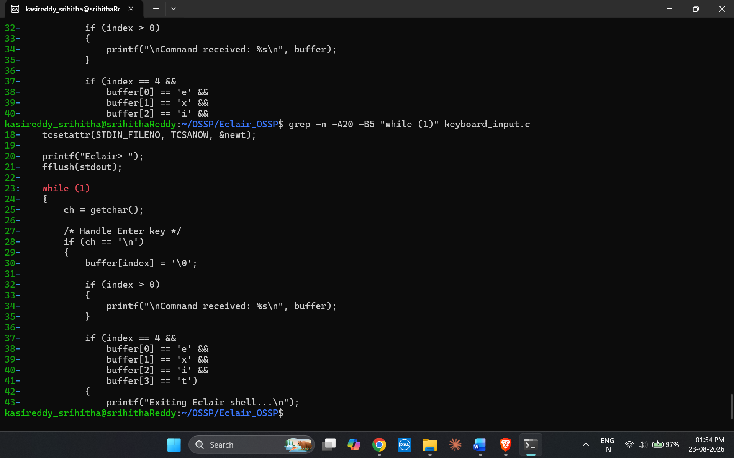

2. Display Prompt
A command prompt is displayed to indicate that the program is ready to receive input from the user.
The prompt provides a clear interface for entering commands and allows the user to interact with the program continuously.
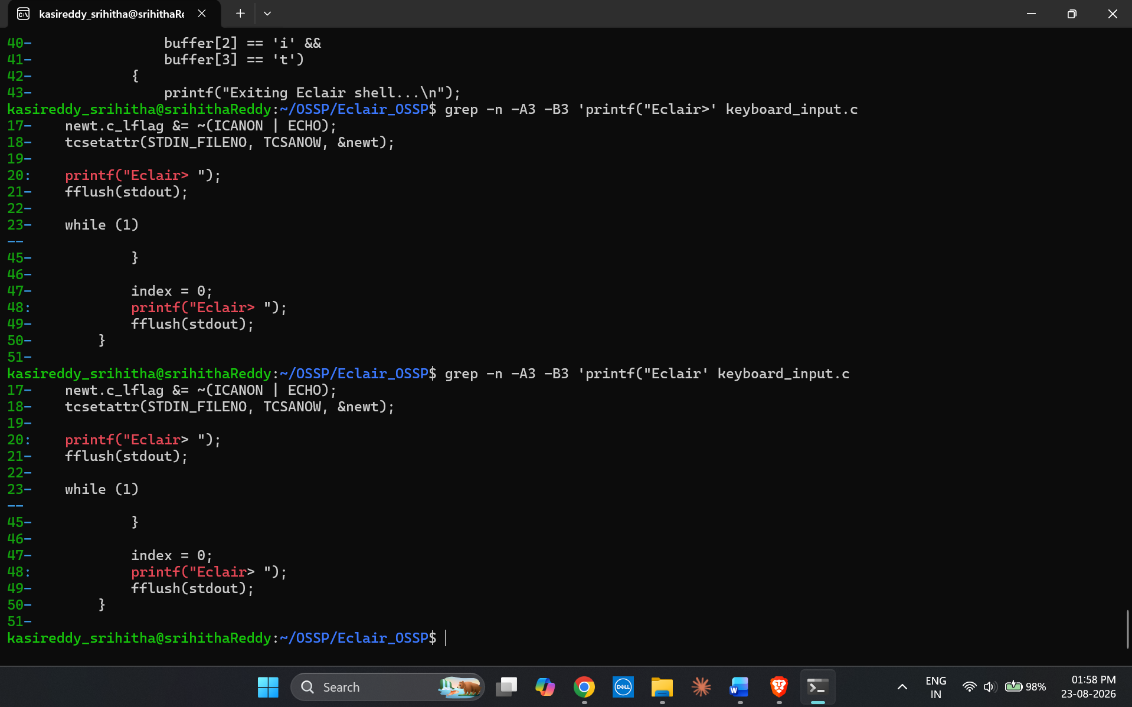

3. Read User Input
The program reads characters entered through the keyboard and stores them in an input buffer.
The input buffer temporarily holds the characters until the user presses the Enter key. This allows the program to process complete commands instead of individual characters.
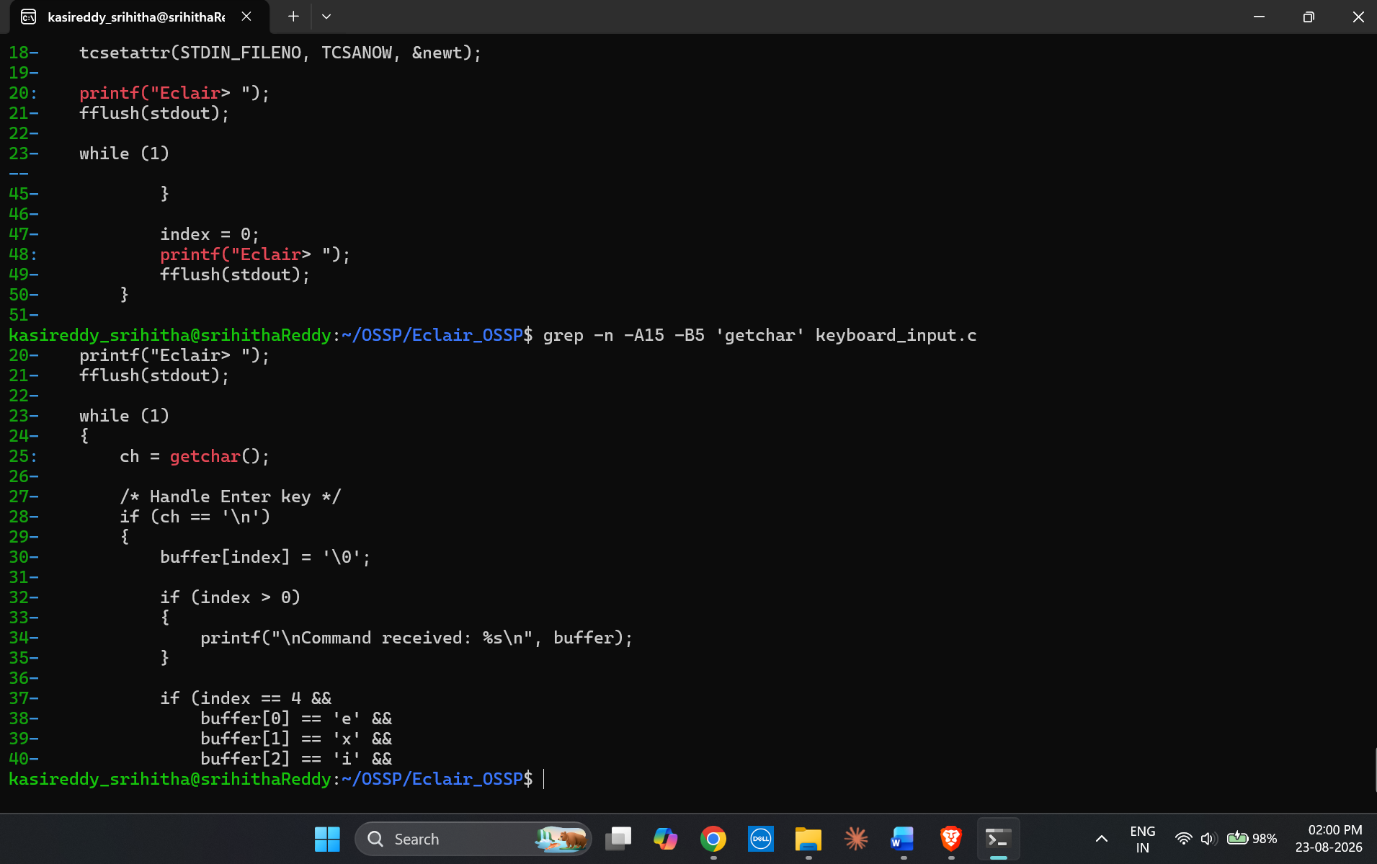
4. Handle Exit Conditions
An exit condition is implemented to terminate the main loop when the user enters the required exit command.
For example, when the user enters exit, the program recognizes the command and terminates the interactive loop.
This prevents the program from running indefinitely and provides a controlled way to exit.
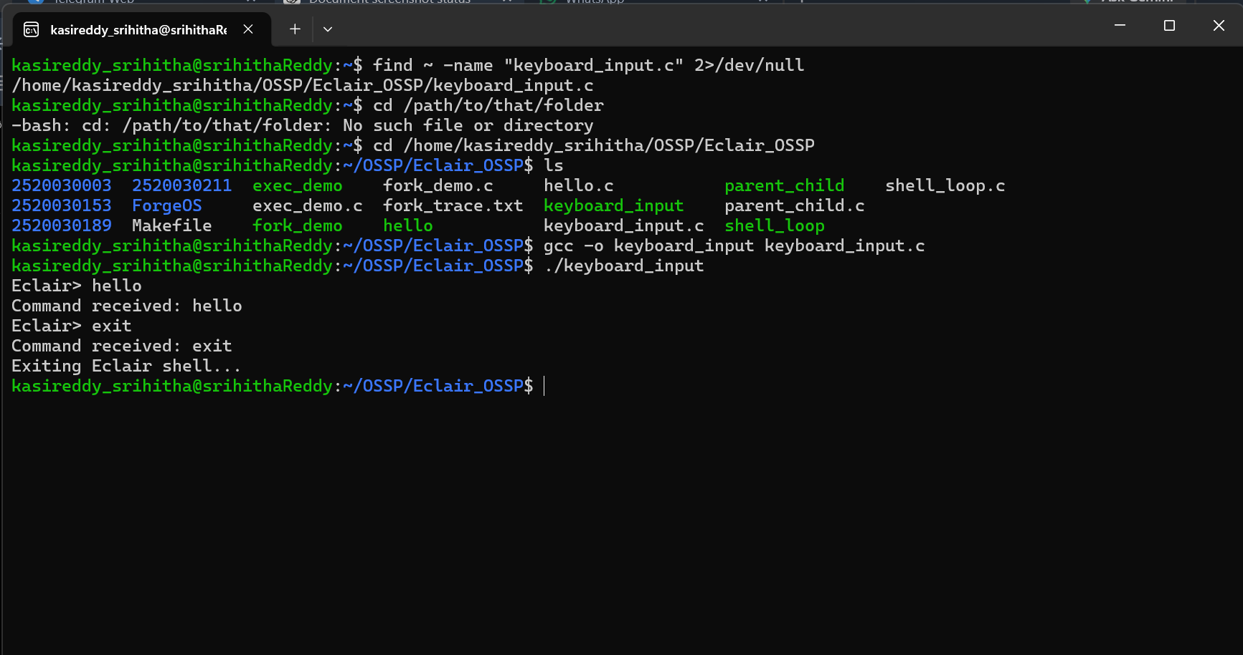

5. Test Interactive Loop
The interactive loop is tested by entering different commands and verifying that the program correctly reads and processes the input.
The program successfully displays the prompt repeatedly and terminates when the exit condition is entered.
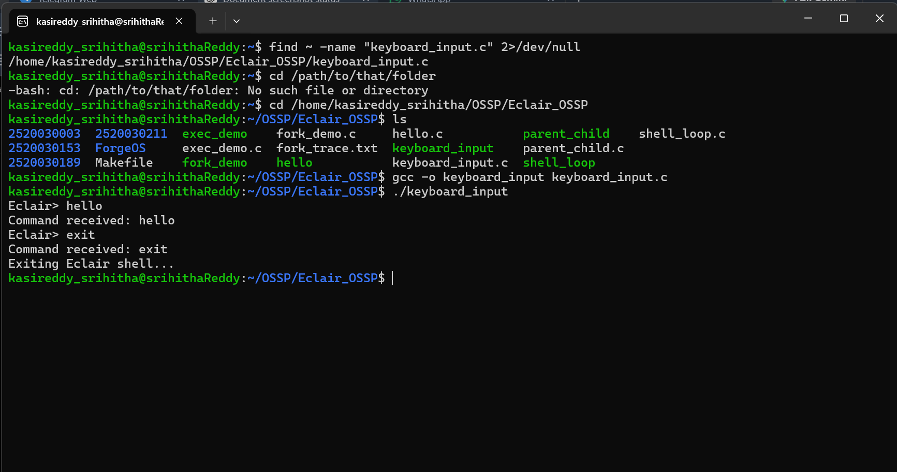

6. Manage Input Buffer
An input buffer is used to temporarily store characters entered by the user.
The buffer keeps track of the current input length and ensures that characters are stored sequentially. After processing a command, the buffer is reset for the next input.
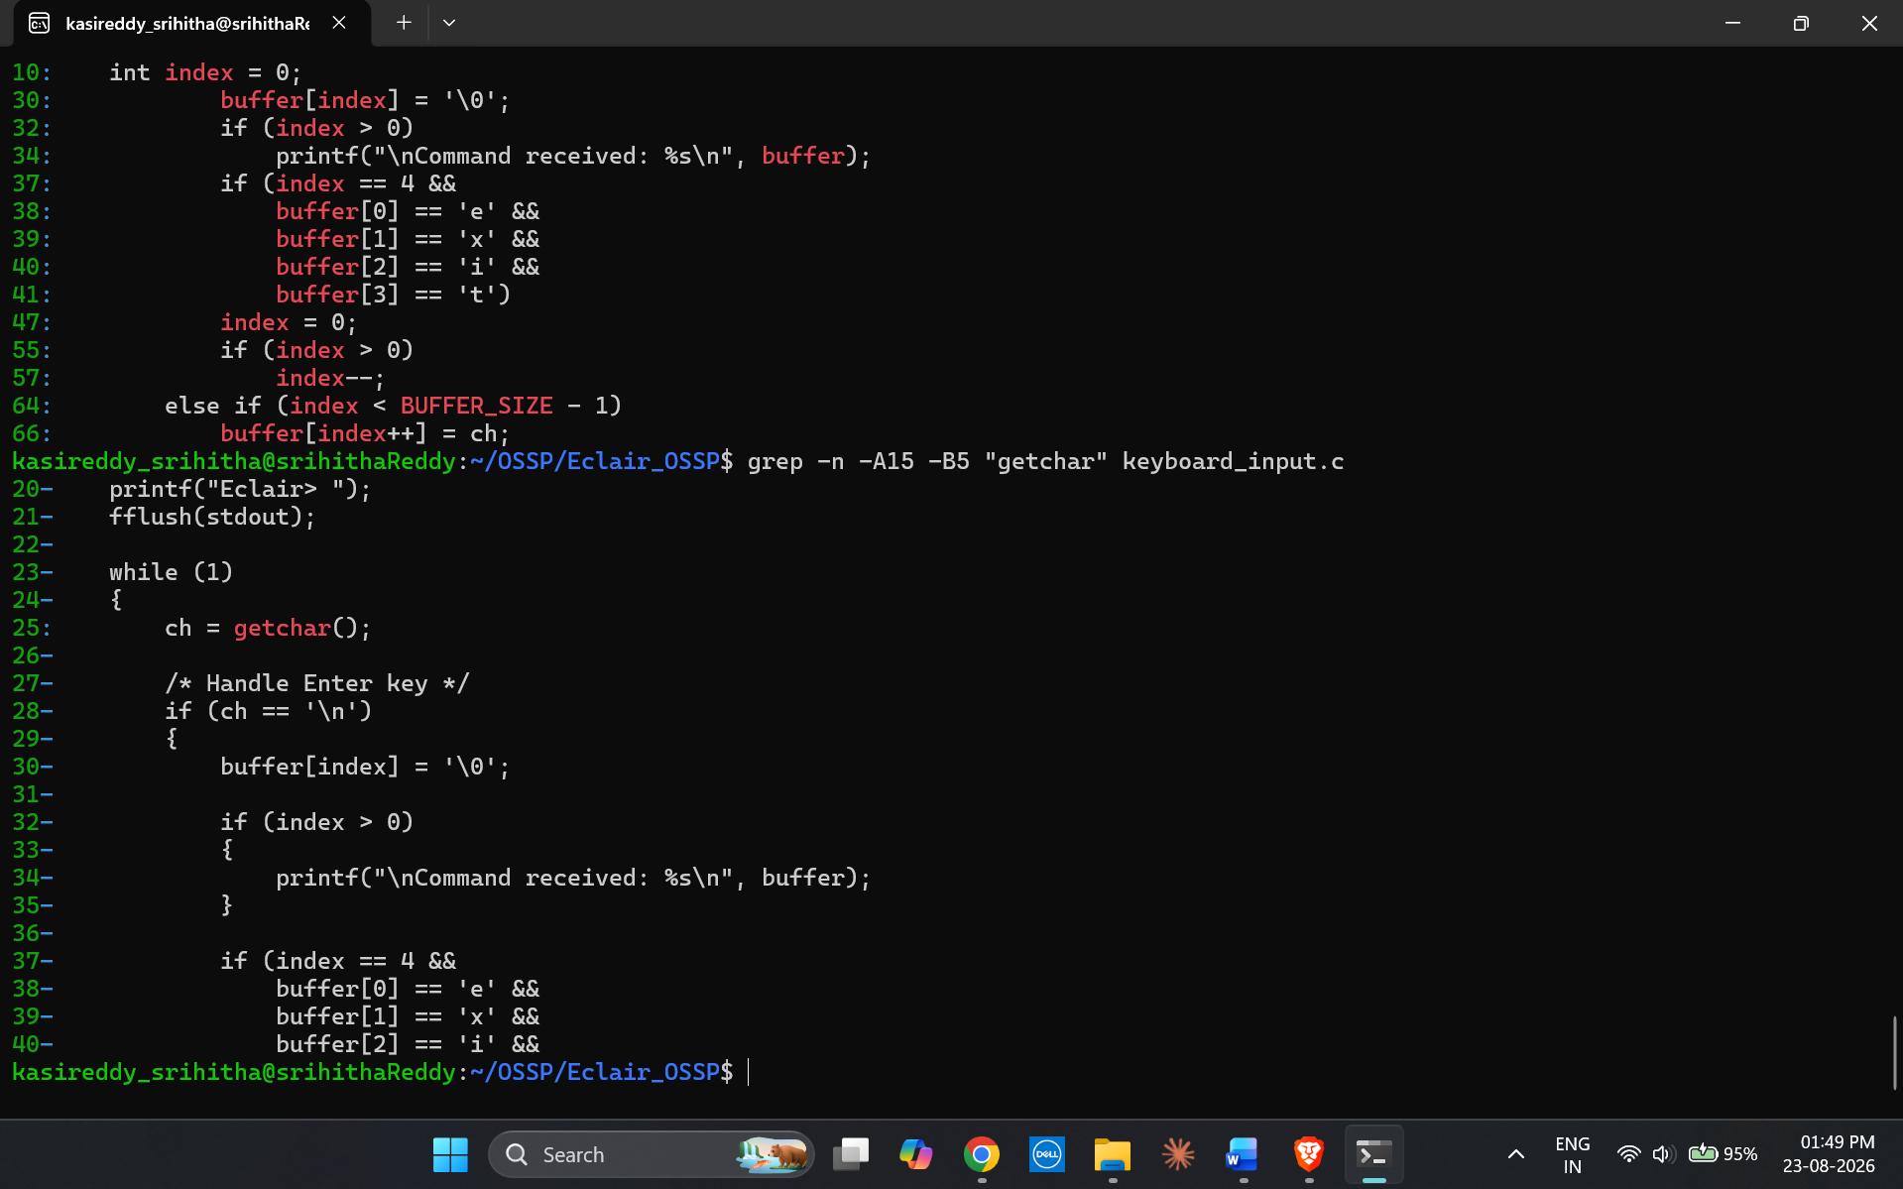
7. Support Multi-Character Commands
The program supports commands containing multiple characters rather than processing only single-character input.
For example, commands such as:
hello
help
exit
can be entered and processed as complete strings.
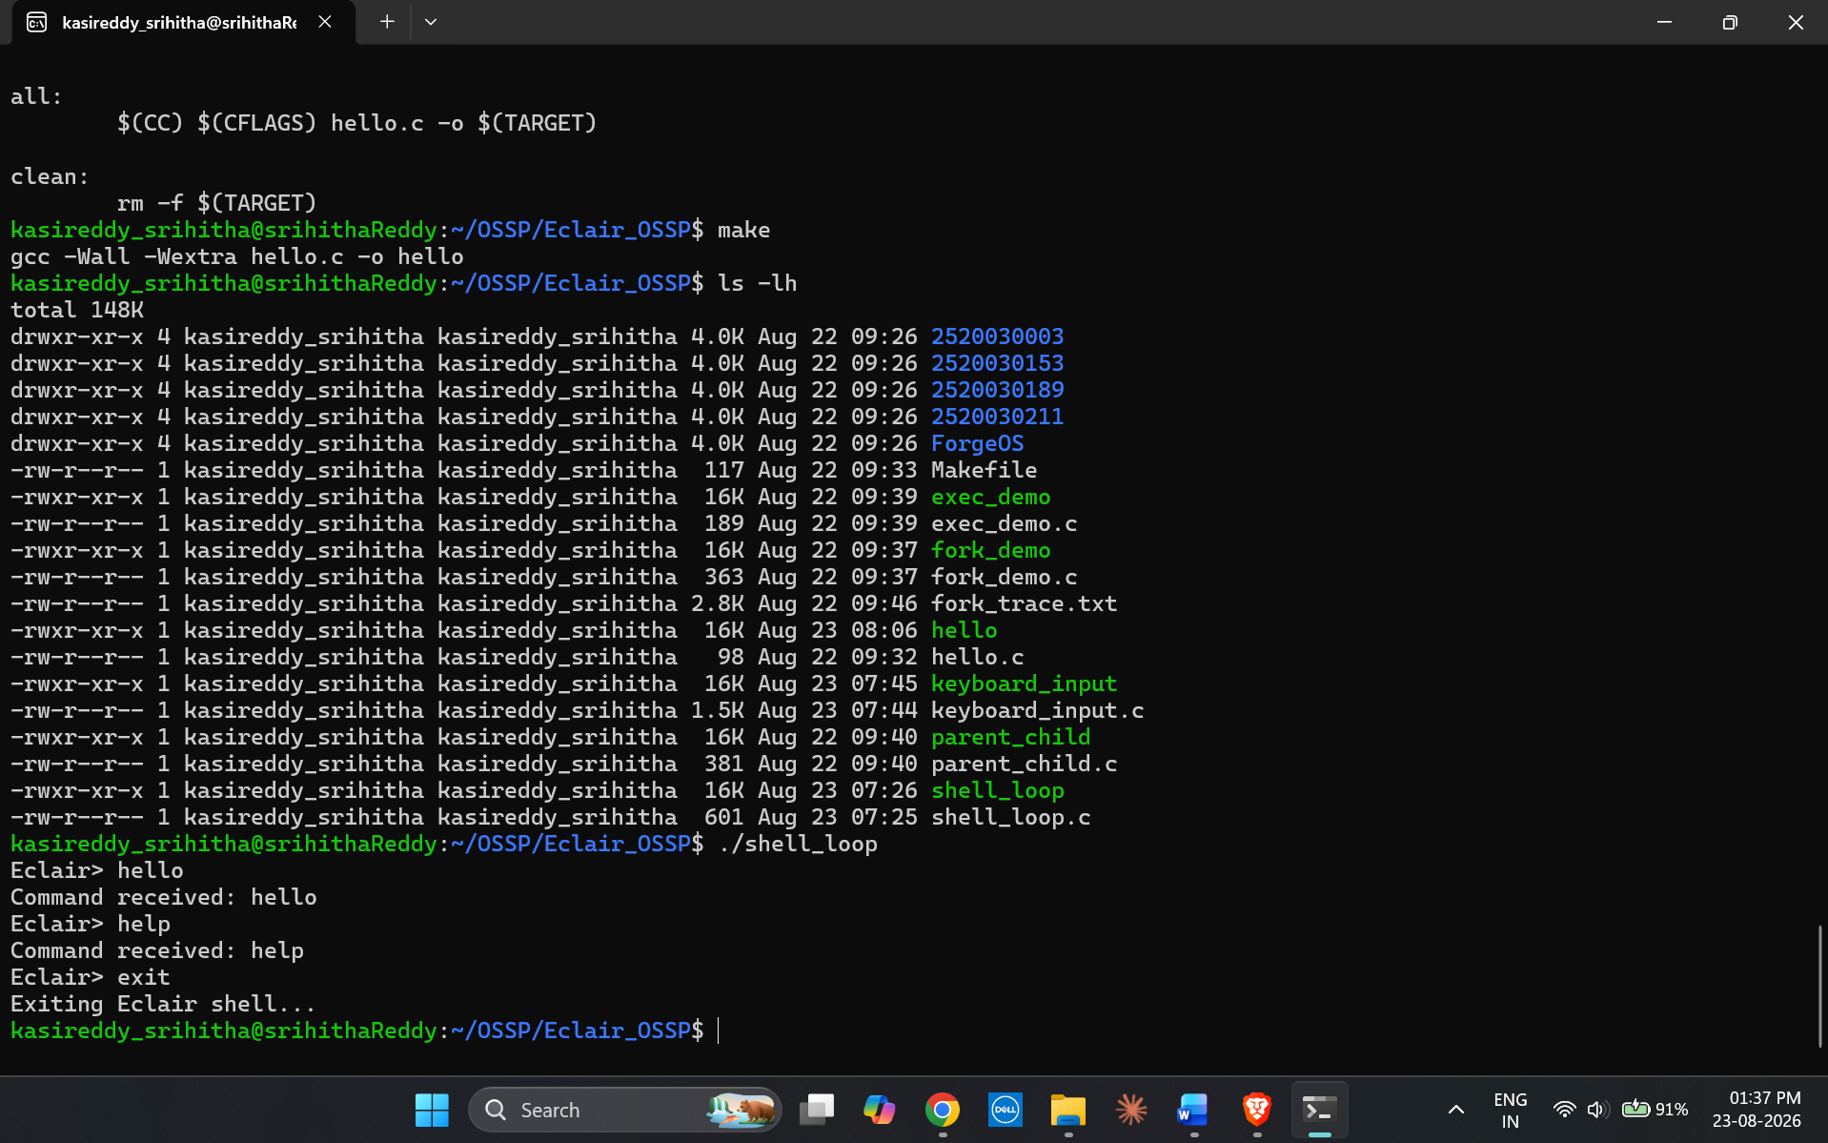
8. Test User Interaction
The complete keyboard input functionality is tested using different user interactions, including normal character input, Backspace, Enter, multi-character commands, and the exit command.
The program successfully captures and processes keyboard input and provides the expected interactive behaviour.
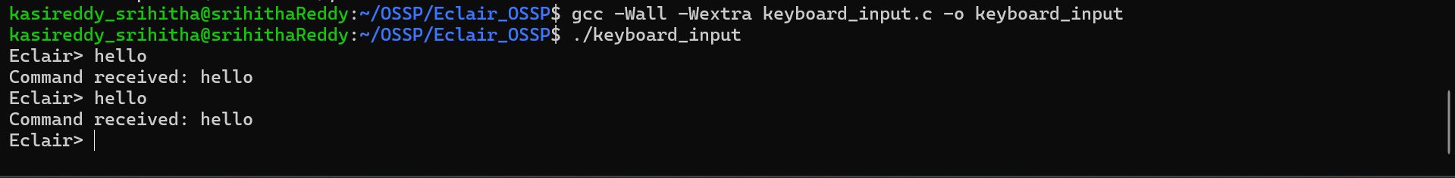
Result
The interactive main loop and keyboard input handling were successfully implemented and tested. The program can display a prompt, capture keyboard input, handle Backspace and Enter keys, manage the input buffer, process multi-character commands, and terminate correctly using the exit condition.

